PCH-Wallet User Manual

Version： | V1.0.1 | No： | TH-TL-POP-02
Security level： | A+ | Department/Project： | R&D department
Product： | PCH-Wallet User Manual | Subsystem：

Contents
I. Brief introduction 3
1. System Introduction 3
2. Background 3
II. Software Overview 4
1. Target 4
2. Function 4
3. Settings 4
III. Operating Environment 5
1. Hardware 5
IV. Instructions 6
1. Create and Import 6
2. Wallet Homepage 10
3. My Settings 15

Brief introduction

System Introduction
This document is POPCHAIN wallet user manual. In this document, we introduce the use of the POPCHAIN wallet so that users can better understand the operation of this system.
The POPCHAIN wallet is a blockchain digital currency wallet that provides you with a safe, simple, stable and convenient one-stop management solution.

Background
This software is a token wallet that supports the ERC20 standard.

Software Overview

Target
To allow users easily master the software use.

Function
Main function description：
- Create a wallet and import it
- Create a wallet:
Enter the ID and password to back up the mnemonic. After verifying the mnemonic, the wallet is created successfully.
- Import wallet:
Enter the mnemonic to restore the wallet. Enter the ID and password, and the wallet is imported successfully.
- The Wallet Homepage
- Transfer: token transaction.
- Collection: Check the wallet collection address.
- Records: transaction records, and transaction details.

Settings
- Wallet Tool
- Change Password
- Backup Wallet
- Import Private Key
- Delete Wallet
- Currency
- Language
- About us

Operating Environment

Hardware
- Android 4.3 or above, iOS 8.0.

Instructions

Create and Import
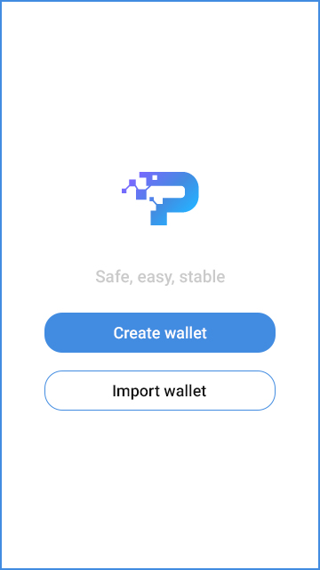
[Main]
- Create Wallet
Enter the wallet ID and password to create a wallet.
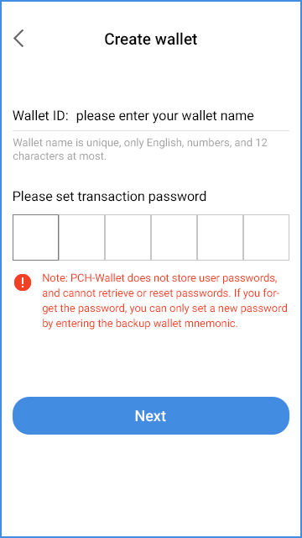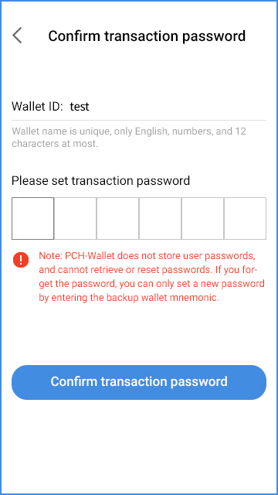
[Create wallet]
[Confirm transaction password]

After setting the transaction password, a mnemonic is generated, and the user is prompted to backup and verify.
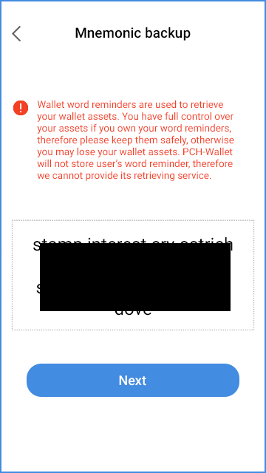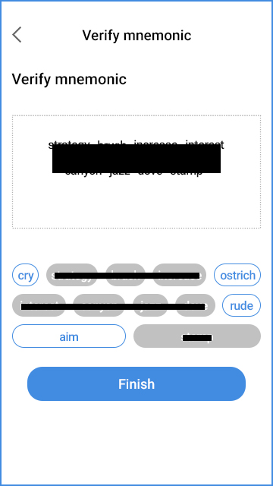
[Mnemonic backup]
[Verify mnemonic]

Note: When verifying the mnemonic, the mnemonic must be consistent with the generated mnemonic order. Click on the button below to add the mnemonic word in the mnemonic display box, and the verification mnemonic box to cancel. After the verification, the wallet is created successfully. If you cancel or exit the program at any previous steps, a wallet is not created.

- Import wallet
Importing a wallet is the same as restoring a wallet, both with a mnemonic to recover.
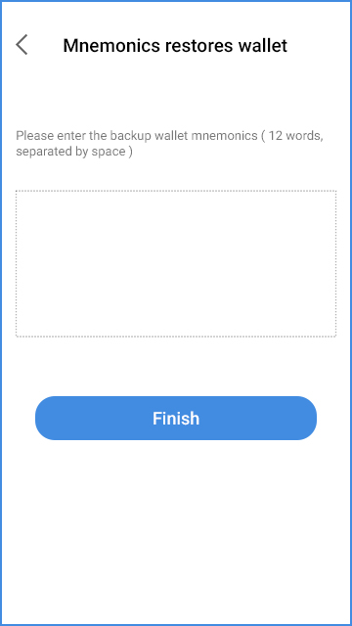
[Mnemonics restores wallet]
Enter manually the back-upped mnemonic and click Finish. Click Next to enter the user ID and the transaction password when creating the wallet. (Fig 2)
When the wallet recovery succeeds, click on“Use wallet immediately,” and the wallet is imported successfully.
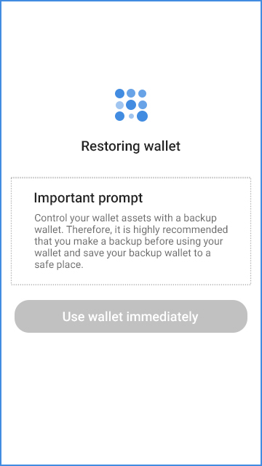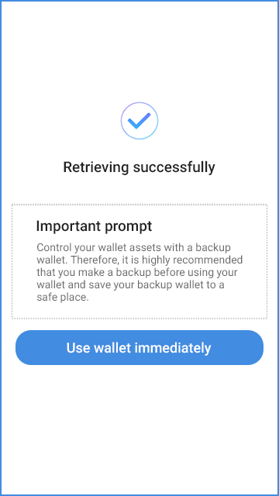
[Restoring wallet]
[Retrieving successfully]

Wallet Homepage
The main function interface includes: Asset list, Add Assets, and Settings.
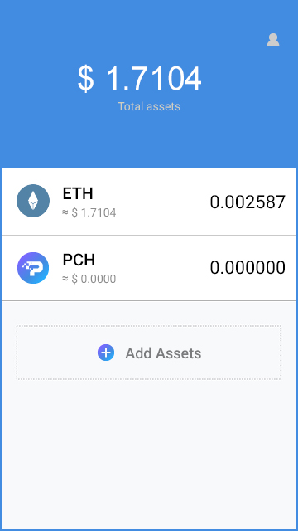
[Wallet Homepage]
- Transaction Record
There are two main function modules in the transaction record interface: Transfer and Receive.
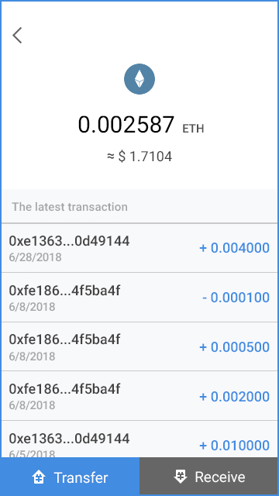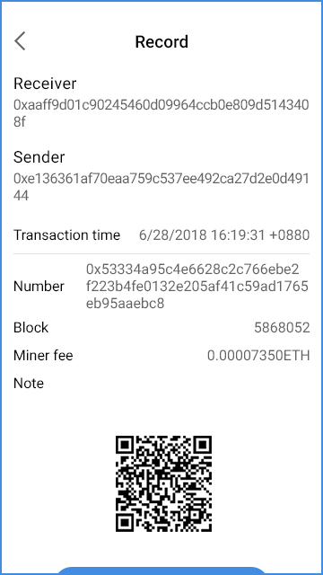
[Transaction Record]
On this interface, you can check the token transaction data, and check the transaction details. In the transaction record details interface, you can view the specific transaction information, and click "Check transaction" to go the official website to check.
- Receive
This interface is for displaying and copying the wallet collection address for collection.
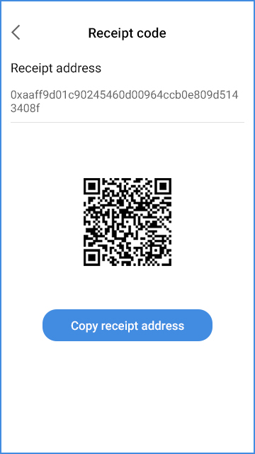
[Receipt code]
- Transfer
On the transfer module, enter the recipient’s wallet address, amount, note (fillable), and miner's fee.
Note: On the right side of the payment address bar, you can identify the QR code address by clicking 'Scan', and you can also identify the QR code image in your photo album.
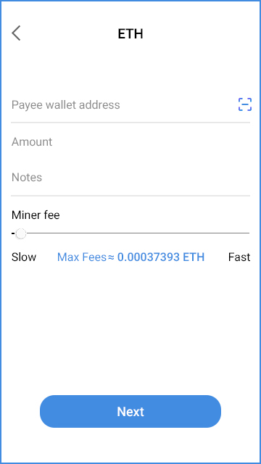
[Transfer]

After entering the information and clicking "Next", the user is prompted to enter the transaction password (the transaction password from the creation stage), and the transaction result is pended after verifying the transaction password.
- Add Assets
Currently, there are only two types of tokensas a default and cannot be changed temporarily.
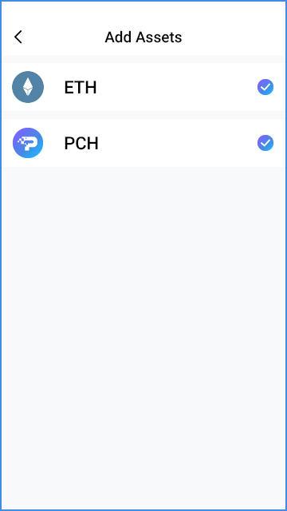
[Add Assets]

My Settings
The main features of the settings interface: Wallet Tools, Currency, Language, and About Us.
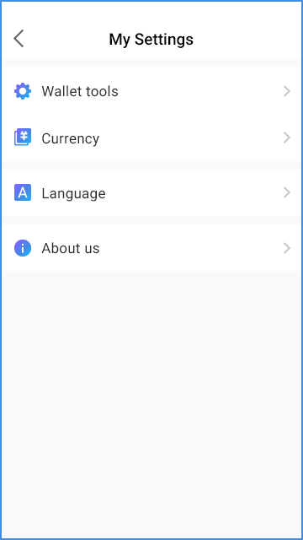
[My Settings]
- Wallet Tools
This function mainly manages the wallet password to modify the wallet backup, export the private key, and to delete the wallet.
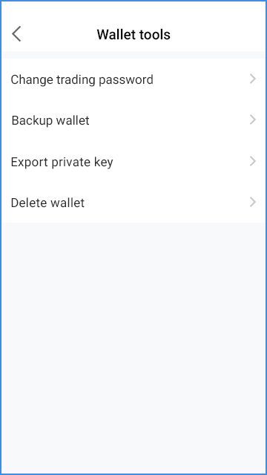
[Wallet tools]
- Change the Wallet Transaction Password
Due to the decentralization of blockchain, wallet transaction passwords cannot be retrieved.
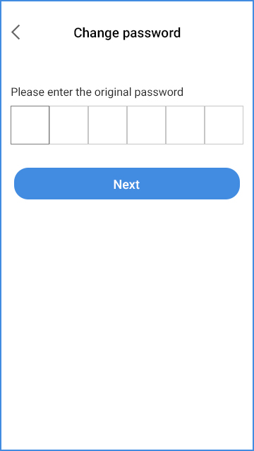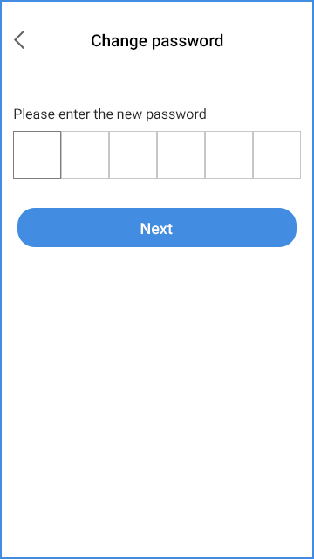
[Change password]
The first step is to verify the original transaction password. Click “Next”, enter a new password, confirm it, and click “Finish”.
- Backup wallet
Backup wallet mnemonics to restore your wallet.
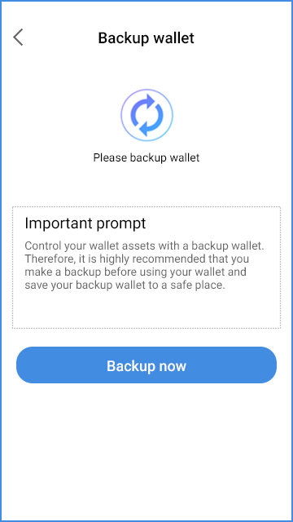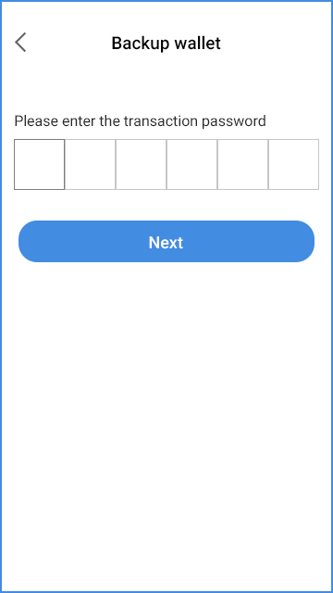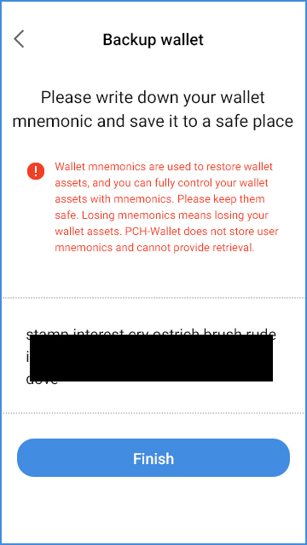
[Backup prompt]
[Verify Transaction Password]
[Backup wallet]

Please write down your wallet mnemonic and save it to a safe place.

- Import Private Key
The wallet private key can fully control the assets of the wallet address.
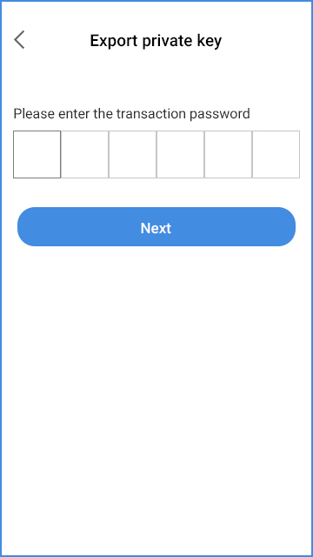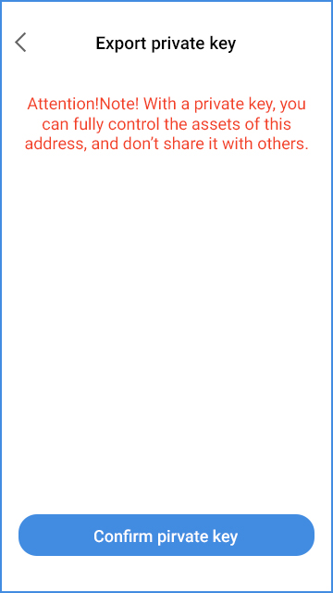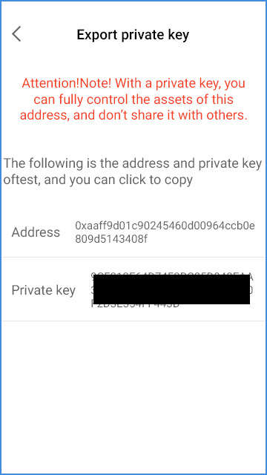
[Verify Transaction Password]
[Private Key Prompt Interface-1]
[Private Key Prompt Interface-2]

- Delete Wallet
Prompt whether to delete the wallet after entering the mnemonic.
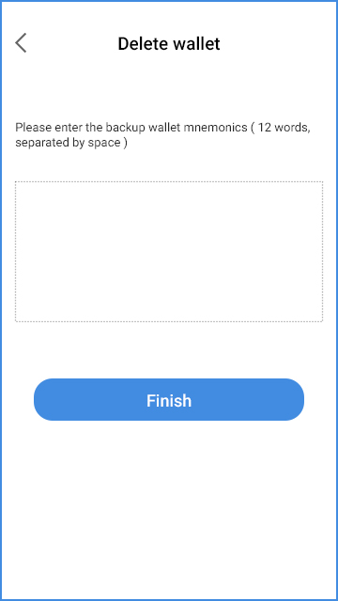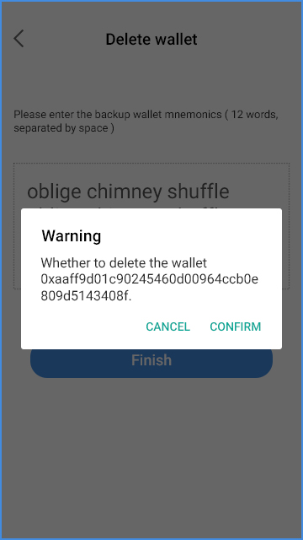
[Delete wallet]
- Choose Currency
- The listed currencies are USD, CNY, and KRW.
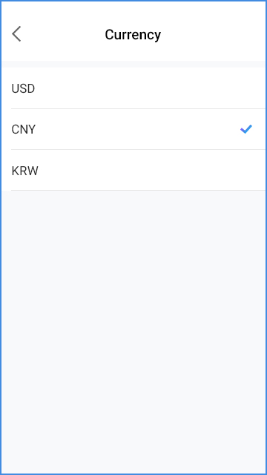
[Currency]

- Choose Language
- The listed languages are: Korean, English, Chinese, and Japanese.
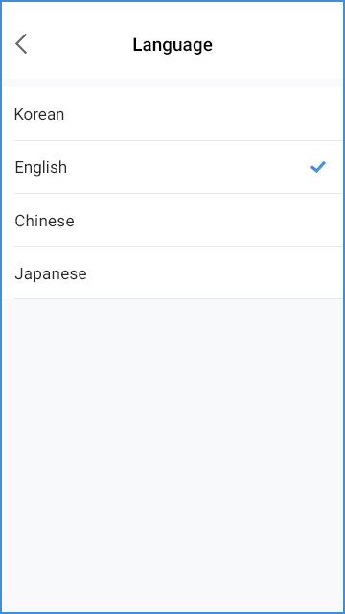
[Language]
- About Us

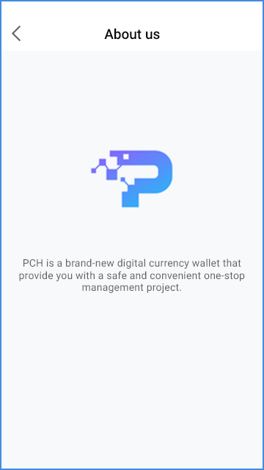
[About us]

